open ./ssh_tt.sh

When cannot access:

https://localhost:19043/spica/login/selectProject.jsf

search port 19043 in ./ssh_tt.sh



Then noti in ssh_tt.sh

Cat service_status to see

It is suspected that



cd uat_ogcio_batch_bin

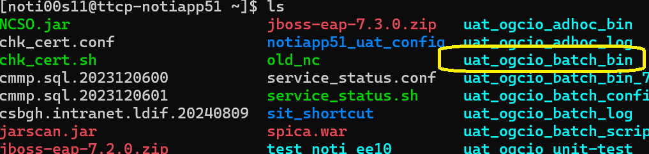

Then start the

./start-batch-UAT.sh

./service_status.sh

